Fruit Ninja Game

Group members:

1-Youssef Ahmed Maher ID:5892

2-Mayar Hussein ID:5384

3-Hania Raslan ID:5369

4-Youssef Alaa ID:5316

5-Ahmed Ibrahim Elsayed ID:5326

Game description:

Intro:

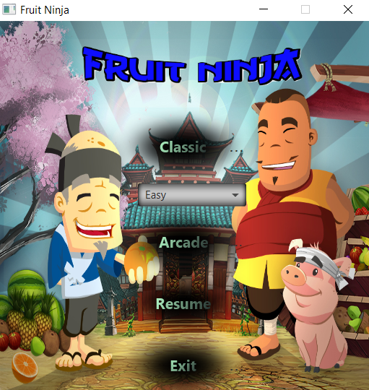

The game consists of two playing modes:

1- Classic mode

2- Arcade mode

1-classic mode:

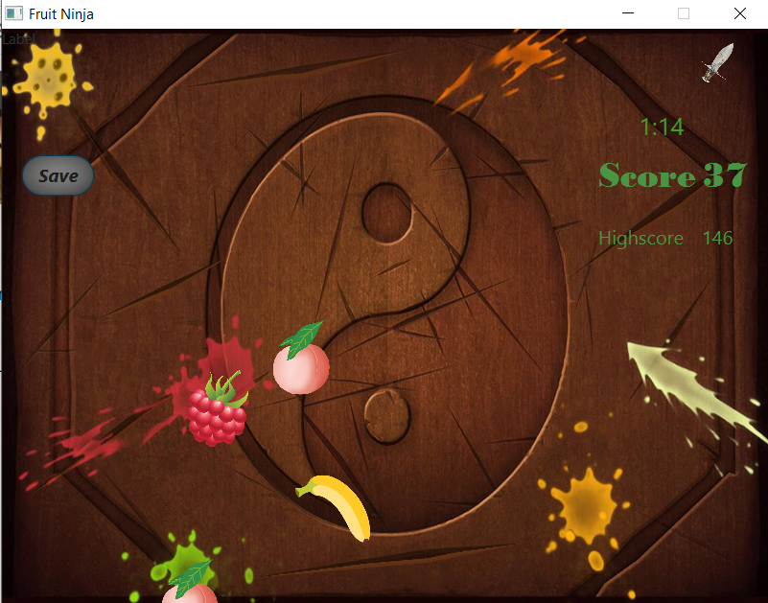

your object is to slice fruits and get the highest score you can get,you have three lives only

you lose one life in one of those cases:

o The fruit drops off the screen without slicing it.

o Slicing Dangerous bomb.

You lose the game in one of those cases:

o Slicing Fatal bomb.

o Losing all your lives ( happens when dropping a fruit or slicing a dangerous

bomb).

Classic mode scene consists of:

O Score label : Displays Score.

OTime label: Displays elapsed time for the game.

O HighScore label: Displays the highest score reached in previous games .

O Save button: saves current state of the game.

Arcade mode:

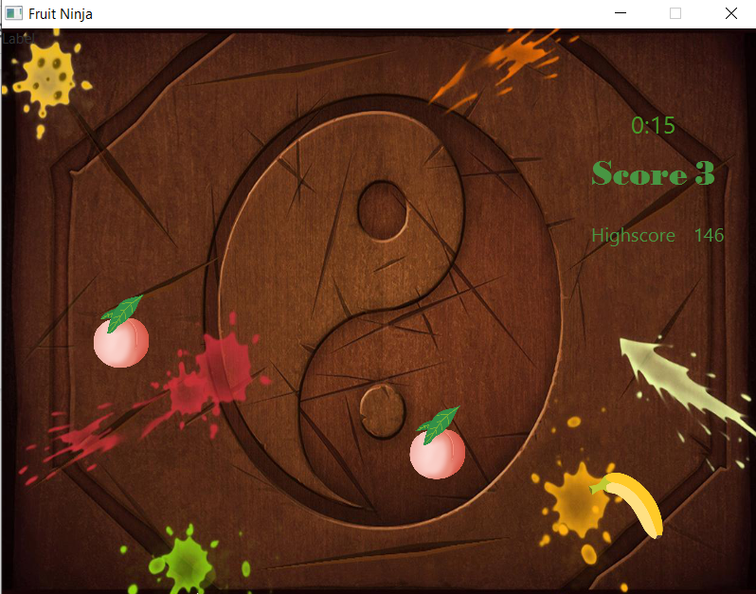

Your object is to slice fruits and get the highest score you can get until the timer ends,you have sixty seconds only.

Dangerous bombs deducts 5 points from your score.

Arcade mode scene consists of:

O Score label : Displays current Score.

OTimer label: Displays remaining time for the game.

O HighScore label: Displays the highest score reached in previous games .

The game consists of three levels of difficulty:

O Easy

O Medium

O Hard

You can choose the suitable difficulty level for you.

Resume button:

Resumes the last saved game.

Exit button:

Exits the game.

Design patterns used in our program:

1-Singleton: used in game object factory.

2-Factory: used in fruits,bombs and special fruits classes.

3-Command: used with Save and load classes.

4-Decorator: used with Special Fruit classes to add new functionality to normal fruits.

5-Strategy: used strategy design patters in implementation of levels.

6-MVC: GameEngine class is the controller, Model Class is the model, AnimationGui class is the view.

Sequence diagram:

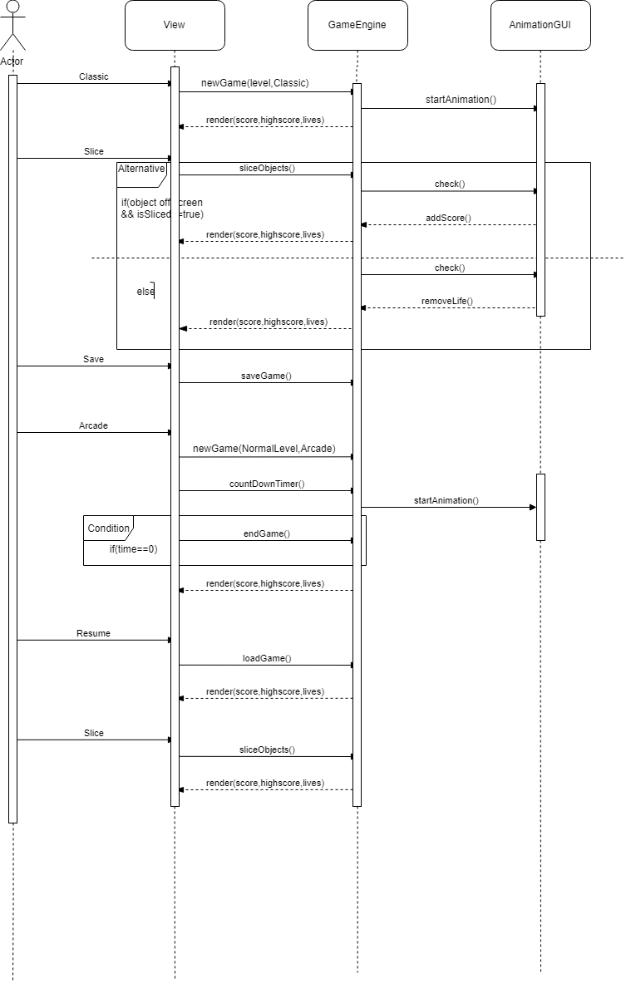

Class diagram :

